Educational Visits Policy
January 2019

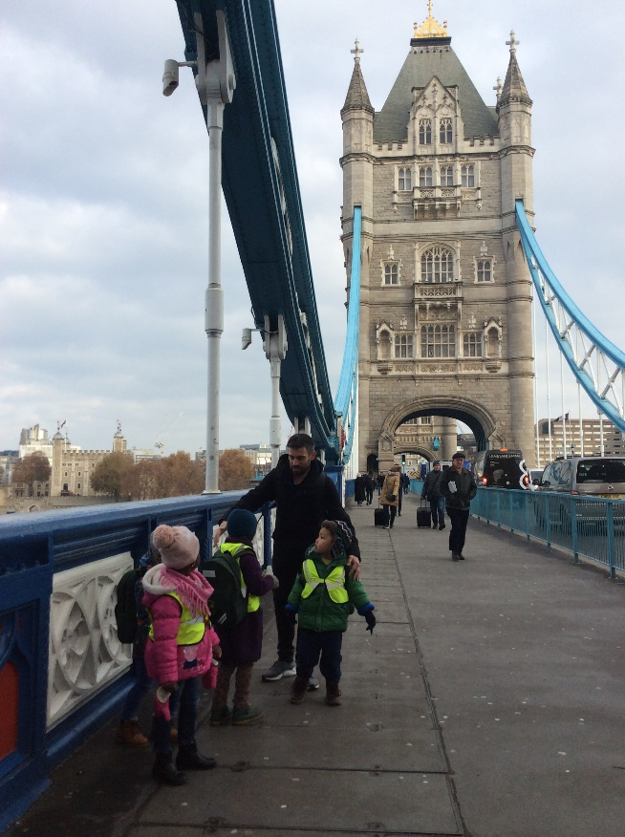

To be reviewed October 2023
Rationale
At Wentworth Nursery School and Children’s Centre we understand the value of well planned, meaningful trips for families and children. We recognize educational visits that are both local and further afield, provide extensive learning opportunities for children. In particular educational visits take into account both children’s interests as well as broadening and deepening children’s curriculum learning.

We are an inclusive school and all our children are given the opportunities to take part in educational visits.

Guidelines

The following guidelines support the planning and implementation of educational visits organised at Wentworth Nursery School and Children’s Centre to ensure that they are safe, enjoyable and high quality learning experiences.

Prior to educational visits the following needs to have taken place:

- Authorization from the Headteacher including discussion of mode of travel and ratios of children to adults.

- A ratio of one adult to two children will be utilized for all educational visits unless an exception is agreed between the Headteacher and parent/carer. There will be at least two member’s of staff attending with one person being the nominated lead person.

- Educational visits letter used as drafted in appendices; otherwise letter must be given to the headteacher before distributed to parents/carers. The letter will clearly state: time of departure and return, as well as mode of travel and number of children and adults attending.

- Visit to venue (if not visited before)

- Completion of Risk Benefit Analysis; which will include what to do if separated from the group and what to do in the event of an emergency such as a bombing or potential terrorist attack.

- Consent forms signed by parents/carers.

- Parents/carers attending educational visits will be attending to support the trip and as such we ask parents/carers not to bring younger siblings. The use of mobile phones during educational visits is not permitted.

On the day of the educational visit

List of children is given at the school office

Any children with medical needs, the appropriate medication is taken. (Only prescribed medication will be administered).

The lead person will take the phone numbers of all children’s parents/carers.

All staff will ensure they take their mobile phones and numbers are known to the school/CC office.

Ensure all staff, children and parents/carers are briefed about the risk benefit analysis.

First aid and spare clothes are taken.

During the educational visit

The Group Leader will ensure the accurate completion of the register before, during and after the trip.

The Group Leader and assistant may decide to change details of the visit or curtail it if they deem it is in the best interests of the children; this will be done as far as possible in consultation with the Headteacher.

Any children in buggies must be removed when travelling up or down escalators and stairs, empty buggies only must be carried;

The Group Leader and assistant will endeavour to photograph and film, where appropriate, some of the experiences of the group to use afterwards to document the visit.

The Group Leader and assistant will inform the Leadership Team of any accidents or injuries to the group during the visit.

After the Visit
The Group Leader and assistant will ensure risk benefit analysis is given to the school office

The Group Leader and assistant will enable any children who return to school unaccompanied are supported to re-join their classes.

All staff who have attended the educational visit will have an opportunity for a short break on their return.

It is our intention that most educational visits are subsequently used as a process of deepening learning and therefore the Group Leader will ensure children have the opportunity to reflect on their visit, possibly looking at images, films and other artefacts related to the day.

Dear Parents/Carers,

Re: Trip to …………………………………………………………..

Your child has been invited to visit the (insert name of venue) on (insert date you are leaving). We will be travelling by (mode of transport) and returning by (insert time). A full risk benefit analysis has been undertaken. There will be two members of staff and two parent volunteers attending. Children will be provided with a packed lunch. Please ensure your child has appropriate clothing including a coat and sturdy shoes.
Please complete and return the permission slip below by (insert date to reply by). Should you have any questions please see (name of person leading the trip).

Yours sincerely,

Ben Hasan

Headteacher

………………………………………………………………………………………………………………………..

I do/do not give permission for (insert name of child )

to visit (insert name of venue and date of trip).

I am/am not able to accompany my child on the trip.

Name of parent/carer:

Signature of parent/carer

Date:

Please return slip by (insert date slip needs to be returned by)

Hackney Children’s Centres
Working together to improve the lives of children and young people

